DP 300. Questions 121-160

121.

122.

123.

124.

125.

126.

127.

128.

129.

130.

131.

132.

133.

134.

135.

136.

137.

138.

139.

140.

141.

142.

143.

144.

145.

146.

147.

148.

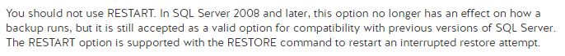

149.

150.

151.

152.

153.

154.

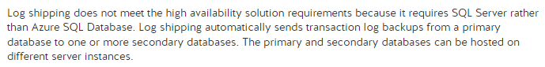

155.

156.

158.

159.



160.

157.

